
Architectural and engineering specifications
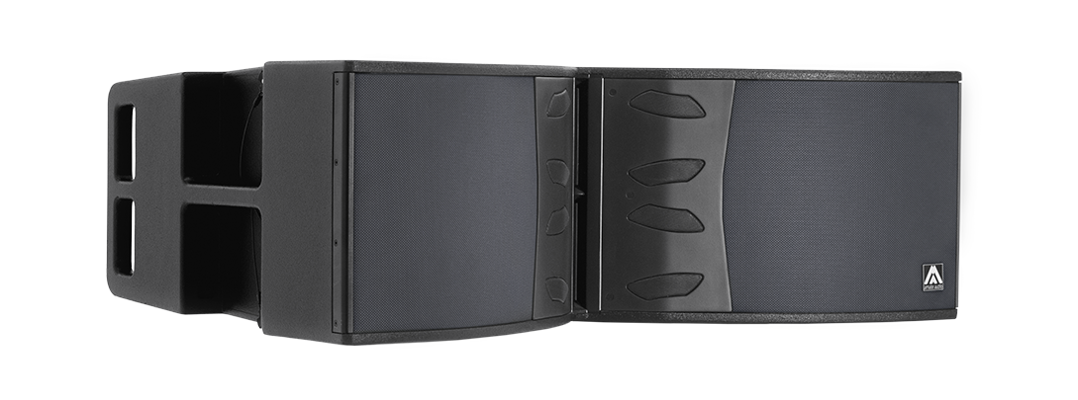
X212AFD

• The system shall consist of a 3-way full range active enclosure. The low frequency transducers should feature two 3-inch voice coil, 12-inch neodymium magnet loudspeakers, the mid frequency transducers should feature four 1.5-inch voice coil, 6-inch neodymium magnet loudspeakers loaded to two mid phase plugs and the high frequency transducers shall feature two 3-inch titanium diaphragm neodymium magnet drivers loaded to a 100º x 8º waveguide. Low frequency transducers shall be rated at a nominal impedance of 8 ohms each one. Mid frequency transducers shall be rated at a nominal impedance of 8 ohms. High frequency transducers shall be rated at a nominal impedance of 8 ohms.

• The usable bandwidth shall be 42Hz to 18kHz (-10dB).

• The system’s horizontal coverage shall be 100º, with vertical coverage of 8º.

• Maximum SPL continuous, measured at 1m under free field conditions shall be 141dB. Maximum SPL peak, measured at 1m under free field conditions shall be 144 dB.

• Enclosure shall be bass-reflex type.

• Enclosure cabinet construction shall consist of Baltic birch plywood. Dimensions shall be 1100 mm (43,3 inch) wide, 372 mm (14,6 inch) high, 657 mm (25,9 inch) deep. Enclosure weight shall be 64,6 Kg.

• Enclosure cabinet finish shall consist of black matt high-resistance Polyurea® paint.

• The front enclosure shall be protected by a 1.5mm steel grilles with acoustically transparent grey cloth.

• The enclosure shall include internal hardware for rigging and shall be used in conjunction with dedicated rigging accessories. Rigging accessories shall be made of stainless steel and must be affixed with special crop resistant screws.

• The amplifier shall be built inside the cabinet, consisting of three channels, with a total power of 2000W/4Ohm for the low frequency channel, 1000W/4Ohm for the mid frequency channel and 1000W/4Ohm for the high frequency channel. The amplifier shall be 3rd generation Class D.

• The amplifier’s power supply shall be switching mode equipped with Power Factor Correction and accept a universal input voltage (85 to 265VAC). The power supply shall protect itself in case of excessive voltage at the mains and rearm itself when the voltage is in the specified range. Mains supply shall be through PowerCon, and a PowerCon Link connector shall be available.

• The analog audio input shall be electronically balanced with a 20kOhm impedance. Connectors shall be XLR type (one female for input and one male for linking). The nominal input shall be of +8dBu, and the input shall accept up to +20dBu without distortion.

• The audio networking input shall operate via the Ethernet RJ45 ports at 1Gbps using Dante™ audio netwoking. It shall manage 1 channel at 48kHz sampling frequency. The system shall be able to connect with other Dante-enabled products over an Ethernet-based network.

• The DSP controller shall be built inside the cabinet and integrated to the power amplifier. The internal DSP architecture shall be 64-bit fixed point, featuring IIR and FIR filters. Analog-to-Digital converters shall have more than 112dB signal-to-noise ratio, 24-bit word size and shall work at 48kHz sampling rate. The controller shall contain factory and user-defined presets. The presets shall be visible and selectable by the user at the cabinet’s rear panel (with built-in touchscreen). The available memory for delay shall allow up to 100m delay (300milliseconds).

• The control and monitoring protocol shall operate at 1Gbps with wired connection and shall be compatible with Dante audio networking, sharing the same network. The connection shall be made through two switched RJ45 ports at the cabinet rear panel, allowing daisy-chained connection to other elements. The maximum recommended number of daisy-chained devices shall not exceed 8 when using Dante audio networking.

• The control and monitoring software shall be capable of monitoring the following parameters: input level, output level per channel, clip limiter activation per channel, amplifier temperature and network connection status. The software shall be capable of selecting different EQ presets for each cabinet, as well as adding EQ or filters, and controlling gain and mute per channel, delay and polarity.

• The loudspeaker system shall be the Amate Audio® Xcellence X212AFD.
• The rigging accessory shall be the Amate Audio® Xcellence TA-X212.
• The stacking accessory shall be the Amate Audio® Xcellence FR-X212.
• The DSP control software should be the Amate Audio® DSPStudio3.
• The audio networking control software should be Audinate® Dante™ Controller

Audinate® is a registered trademark of Audinate Pty Ltd.
Dante™ is a trademark of Audinate Pty Ltd.

June 2023

